|  |
| --- |
| **University of Missouri Kansas City** |
| **SWINNEY GENIE** |
| **Advanced Software Engineering- Project Plan** |

**Sirisha Pakalapati**

**Sree Vishnu Satarajupalli**

**Prakash Garapati**

**Sriharsha Chowdary Veerepalli**

**Project Proposal**

**Introduction:** As we all know that in Swinney Recreation Center, we play many games like badminton, basketball, football etc... The main problem over here is at times people get vexed up to play there due to few reasons like there may be no place in the court i.e. the courts may be already filled up or there are no available playing stuff.

So **our main motto, is to develop an application on Swinney Recreation Center**, to check the availability of courts i.e. whether the courts are filled or not and also to check the availability of badminton Racquets and basket ball's all different playing stuff.

**Project Goal and Objectives**

* **Overall Goal:**

Our overall goal is to create a mobile application for Swinney recreation center of UMKC which serves the purpose of reserving the courts and finding the availability of the playing stuff and finding when the courts will be available free so that they can come at that time for playing.

* **Specific Objectives(Problem Statement):**

The main objective of our project is to help people without wasting their valuable time. By using this app we can know whether the courts are occupied or not. And this in turn saves more energy. In this project, we will have an admin and he should take all the login details of students who are entering into the Swinney and to which place they are heading to i.e. for badminton or basketball etc. The same admin will also be held responsible for check in items i.e. giving badminton racquets and basketball etc. Each user (Student) has to check out all items while they are going. After entering login details, the admin has to mark the court in the system as the court is filled so that the students can know the court is filled by using the app from wherever they are. After check out, admin has to unmark it so that the people can know the court is vacant now.

* **Significance:**

This application is very useful as we can use it in Real time. The college management has already developed some apps, but with that we can know only the timings of swinney. So our main significance to develop this app is to check a court i.e. whether it is occupied or not. By using that application we can save time and energy. Swinney is based on a first come first serve i.e. whoever comes first will have the court occupied if the court is available and it will be excruciating to people who came at last, so at this scenario our app will be very useful.

**Project Background and Related Work**

* **Work done by Others:**

Many applications are based on the reservation and checking of the available stuff. All these applications are mainly for the use of a single person gives the results according to the user only. But this application takes into account all the students of UMKC and helps in reserving the courts of the Swinney Recreation center and finding the available playing items.

The Application we have planned to develop is different from all other applications in the following ways:

1. It provides the availability of the courts in the Swinney recreation center.

2. The student who wants to know the information about courts and playing items has to first join into our application by creating a username and password.

**4. Proposed System**

4.1. Requirement Specification

Functional Requirements:

* Users have to first register by entering their first name, last name, student id, email id and password.
* All the information about the playing stuff is there in the website.
* Users will get notifications about any game events are held in UMKC.
* Users can select the particular game he is interested in.
* While entering into the profile of the game we will get the availability of the courts and availability of the playing of that game and we will get the information about when the court will be free.
* Users can reserve the courts and playing stuff when available free, in the website.
* Users can like the application and post on Facebook and tweet on twitter.

Non Functional Requirements

* The application must give results pertinent to the preferences set.
* The application should give results as fast as possible without any lag.
* The user interface should be user friendly.

Business Requirements

* System: The system should return results as fast as possible without any delay.
* User: All the users want the results which satisfy every member of the group.

Business/Domain Model:

Domain Model consists of major classes in the basic management of the project. It includes all the crucial abstractions of the business environment. It is like the building block of the project.

Technological and Architectural Requirements:

Technological requirements we need HTML JavaScript, CSS for the user interface. AJAX is also used to avoid total rendering of a page after any postback. We need the information about the total no courts and playing stuff available in the Swinney. Architectural requirements include browser which can open the web application.

**4.2 Framework Specification (to be done : interface)**

**4.2.1 Assumptions and Principles**:

The users are assumed to have mobile or compatible browsers to view the web pages. The user creates an account with their name and password.

The principle used here is updating the information about the courts and the playing items when they are returned to the front desk.

**4.2.1Methodologies and Algorithms**:

The algorithm used here in this application is first in first out scheduling algorithm where the user who comes logs in first and who reserves first gets the court reserved.

**4.2.4 System Architecture Diagram**:

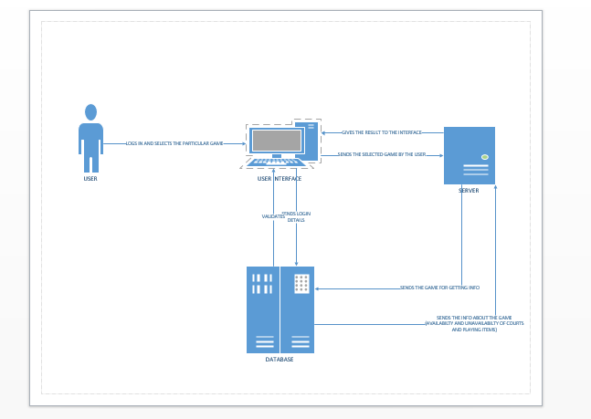

**3) SYSTEM SPECIFICATION:**

* **NEW SERVICES TO BE BUILT**: We are building a Mobile application in which any student can reserve the courts and playing stuff in Swinney recreation center and can view the information about at what time the courts and playing stuff will be free so that they can reserve.
* **CLASSDIAGRAM**: 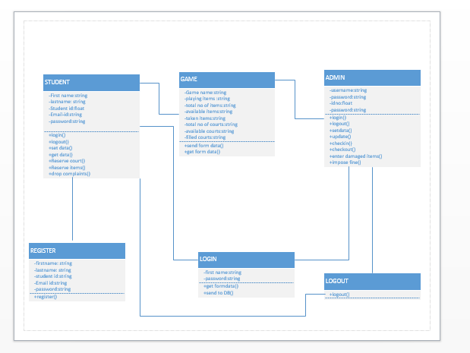
* **SEQUENCEDIAGRAM**: 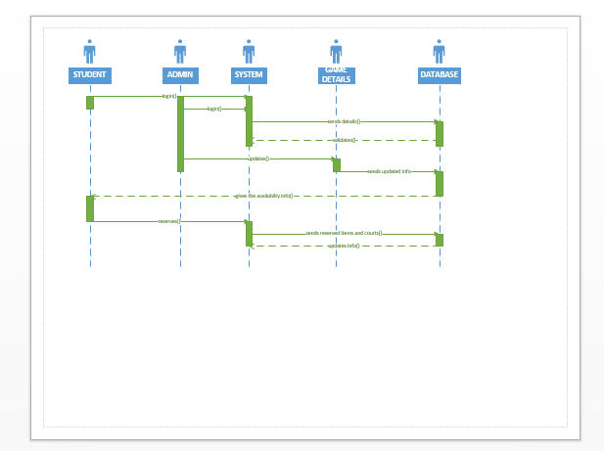

**SERVICE SPECIFICATION**:

**Operational description**:

**Input for services**: In our application input is the data entered by the user.

**Output for services**: In our application output will be the list of courts and items of games available for available for playing

**Constraints:** The students who are not enrolled in UMKC cannot have access to this Application.

**Exceptions:**

**Service flow:** Here in this application after the student logs in he has to choose the particular game he is interested in and it goes to the database and the database sends the information of the available courts and playing items to the user.

**Priorities**:

1) Processing is the main priority in our application.

2) Preference of the student ie; game he/she is interested in is also the priority in our application.

**DESIGN OF MOBILE CLIENT:**

**Features:** submit button, Login button, save button

**Styles:**  CSS

**Technologies**: HTML

JavaScript

Jquery Scripting

IBM smart cloud

SQL or MYSQL

**V) Project Timelines, Members, Task Responsibility:**

**First Increment**: As for the first increment, we want to install all software’s like Visual Studio etc. and tools required for "SWINNEY GENIE" project.. Then we want to create the sign in page for users who want to see whether courts are full or not and also develops admin interface page for the users who are entering into swiney So the Timeline is MAR 07.

**Second Increment**: For this increment, we want to develop a code for storing values into database and also checking the details of user whether it is correct or not. Also develops a sign up page for new users who want to see whether court is full or not. So the Timeline is MAR 21.

**Third Increment:**  In third increment we will concentrate more on user interface i.e. by showing the entire map of swiney. Whenever user wants to check court, he/she just clicks on that map then it will shows by displaying some game and also develops code for button clicking events to show that map. We also want to create signup page for users and also uses the services like GET method to update values into database. For this increment the timeline is APR 11th.

**Fourth Increment**: In the final phase of project, we want to connect all interfaces and we want to deploy the entire project into IIS server.

**Vi) RISK MANAGEMENT**:

* Risks in a project are identified and generally they can be resolved by using some efficient methods. Minor risks involved in our project are:
* Users may forget their passwords.

**Vii Hosting**

All the work is posted to the github including project plan document and the link is:

Scrum Do link is posted to the link given.

Web Client is to be Developed in 1st increment.

**Viii BIBLIOGRAPHY:**

1. http://www.umkc.edu/src/